**Beet Seed**  **— відпрацюй навички на базовому рівні.**

Протестуй UI/UX сайту [Оксфорд Медикал](https://oxford-med.com.ua/). В Google docs створи 5 багів з дотриманням усіх вимог до оформлення багу.

**Beet Sprout — детальніше заглибся в практику.**

Проведи кросбраузерне тестування знайдених раніше багів у трьох різних браузерах. Додай результати до зафіксованих раніше багів.

**Bug report 1**

**Home page: Information banners in the Carousel element do not switch.**

Description: URL:<https://oxford-med.com.ua/>

1. Open oxford-med main page.

2. The Carousel element is present on the main page.

Expected result: You can switch information banners in the Carousel element to see the next of four information banners.

Actual result: There are no information banner switches in the Carousel element.

Attachments:

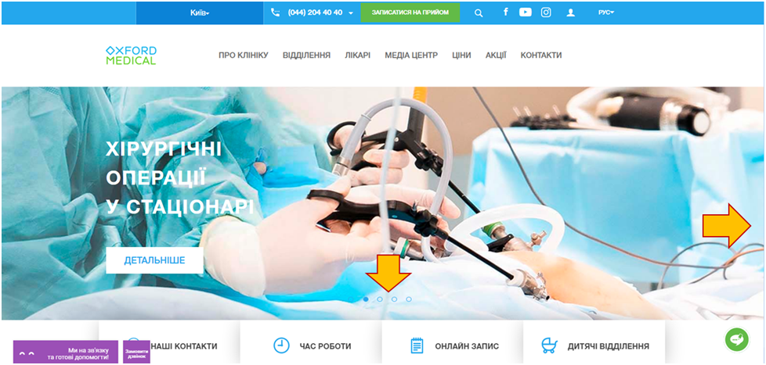

Tested in three browsers: Chrome, Opera, Firefox - the result is the same. The bug is present.

**Bug report 2**

**Home page: The "Information" block at the end of the page is not completed.**

Description: URL:<https://oxford-med.com.ua/>

1. Open oxford-med main page.

2. Scroll to the end of the main page.

3. Come to the "Information" block.

Expected result: The "Information" block is completed.

Actual result: The Information block is not completed, unlike the other blocks.

Attachments:

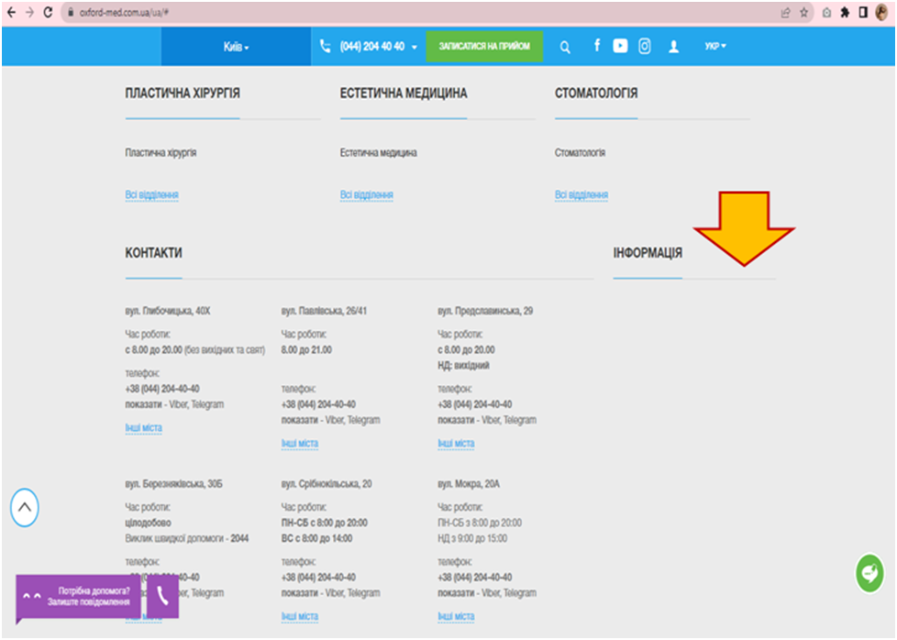

Tested in three browsers: Chrome, Opera, Firefox - the result is the same. The bug is present.

**Bug report 3**

**Home page/UA/About: The link to check the validity of the license does not provide any information.**

Description: URL:<https://oxford-med.com.ua/>

1. Open oxford-med main page.

2. Click on the "About the clinic" button.

3. Scroll down to information about Our licenses.

4. We see a message: "The validity of licenses can be checked here".

5. Click on the link.

Expected result: Information about the validity of the license is opened.

Actual result: The form for requesting the Ministry of Justice of Ukraine opens. Searching by full name and EDRPOU code opens the following form. Information about the validity of the license is not opened.

Attachments: Click on the link:

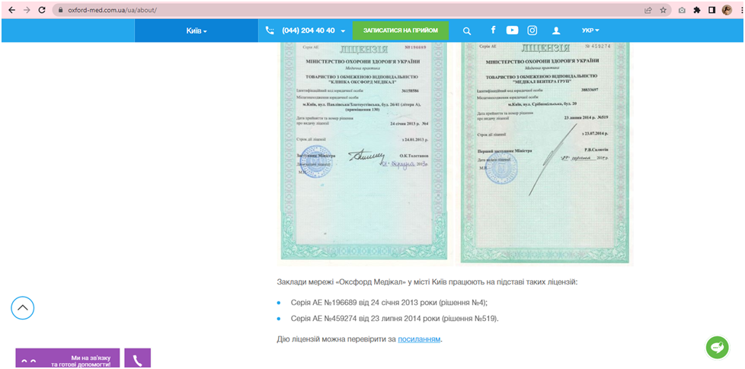

Follow the link:

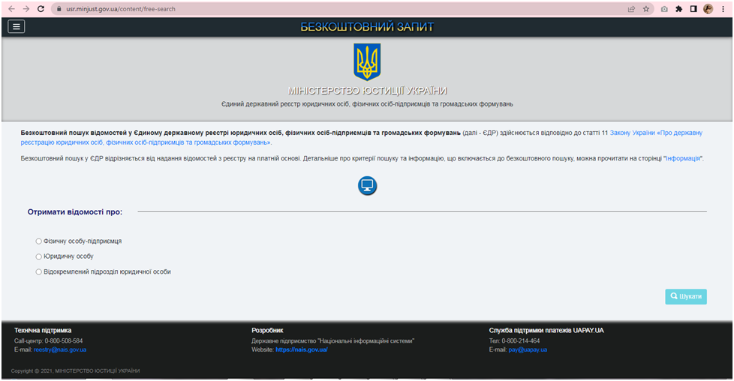

Searching by full name and EDRPOU code:

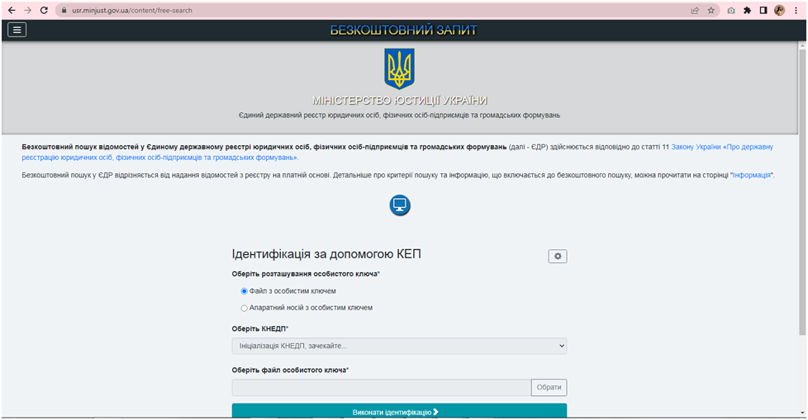

Tested in three browsers: Chrome, Opera, Firefox - the result is the same. The bug is present.

**Bug report 4**

**Home page/ua/services/vakcynacya: The link to influenza does not open in the list of vaccinations.**

Description: URL:<https://oxford-med.com.ua/>

1. Open oxford-med main page.

2. Click on the " Departments" button.

3. Click the "All departments" button in the Polyclinic subsection.

4. Select Vaccination in the list.

5. Follow the link Influenza in the list of vaccinations.

Expected result: The link with information about the flu opens.

Actual result: The link does not open. 404 error: Sorry, the requested page was not found.

Attachments:

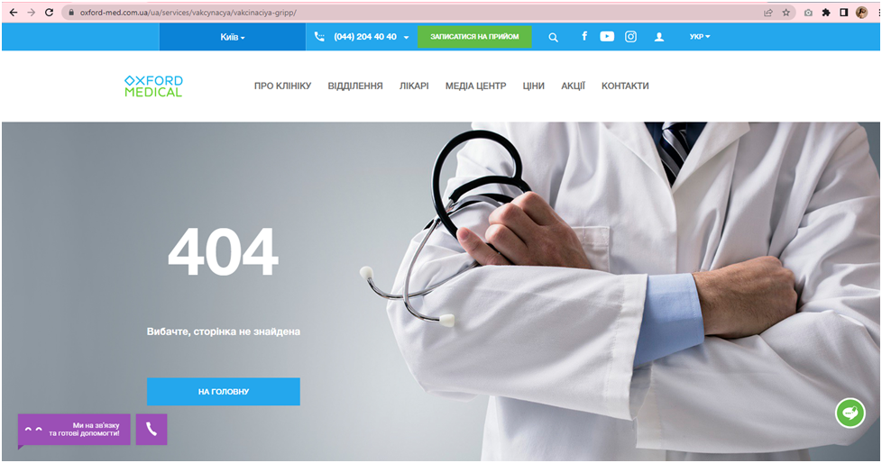

Tested in three browsers: Chrome, Opera, Firefox - the result is the same. The bug is present.

**Bug report 5**

**Home page/ua/services/detskoe_uzi: The link to ultrasound does not open in the description of hip ultrasound.**

Description: URL:<https://oxford-med.com.ua/>

1. Open oxford-med main page.

2. Click on the " Departments" button.

3. Click the "All departments" button in the Diagnostics subsection.

4. Select Choose Pediatric ultrasound. in the list.

5. Select Ultrasound of the hip joint of the child from the list.

6. Follow the link to the ultrasound in the description of hip ultrasound.

Expected result: The link with information about to the ultrasound opens.

Actual result: The link does not open. 404 error: Was not found on this server.

Attachments:

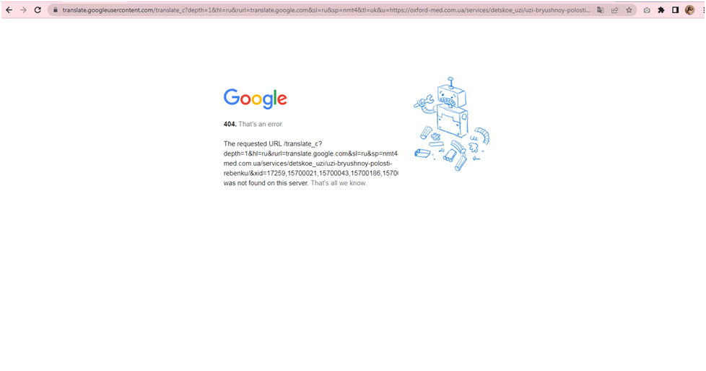

Tested in three browsers: Chrome, Opera, Firefox - the result is the same. The bug is present.

**Mighty Beet — різнобічно опануй тематику уроку.**

За допомогою Developer Tools зафіксуй використаний шрифт, його розмір, колір та колір бекграунду наступних елементів сайту [Оксфорд Медикал](https://oxford-med.com.ua/):

**1.** **номер телефону у хедері:**

Шрифт та розмір: 16 px Helvetica Neue Bold, sans-serif

Колір: #ffffff color description : White.

Колір бекграунду: #24a7ed color description : Bright blue.

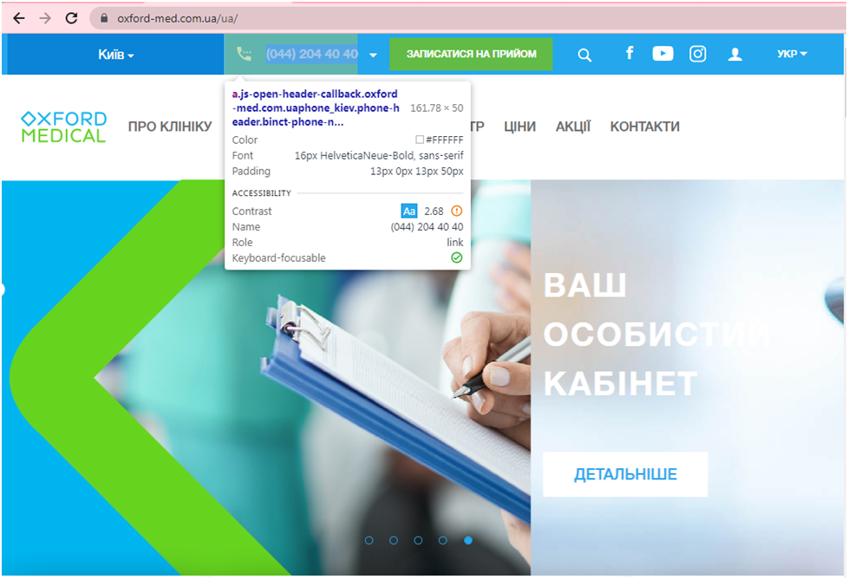

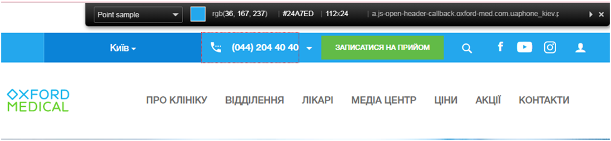

**2.** **ім’я асистента при виклику чата допомоги**

Шрифт та розмір: 13 px Roboto, sans-serif

Колір: #cccccc color description : Light gray.

Колір бекграунду: #ffffff color description : White.

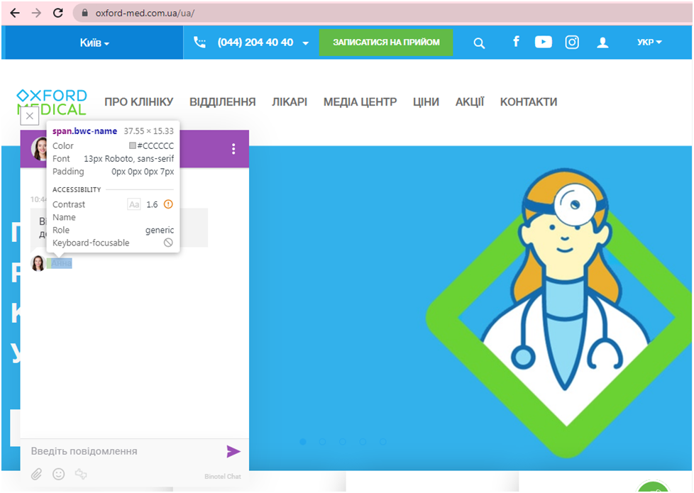

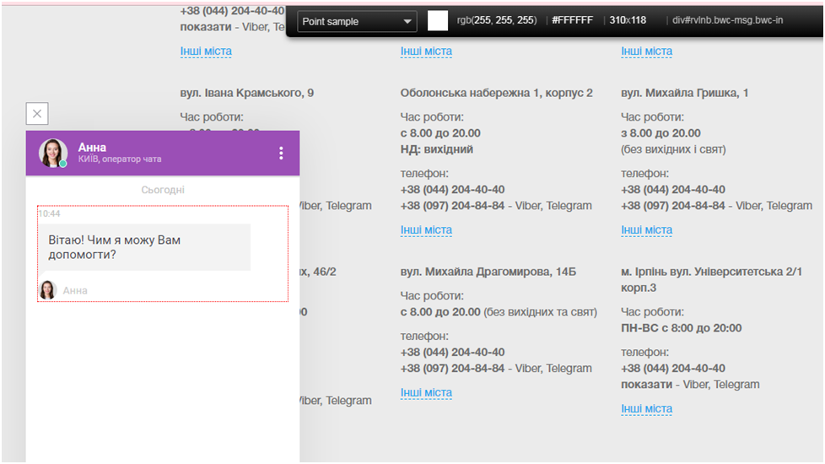

**3.** **кнопка “інші міста” у футері сайту**

Шрифт та розмір: 14 px Helvetica Neue, sans-serif

Колір: #24a7ed color description : Bright blue.

Колір бекграунду: #ebebeb color description : Very light gray.

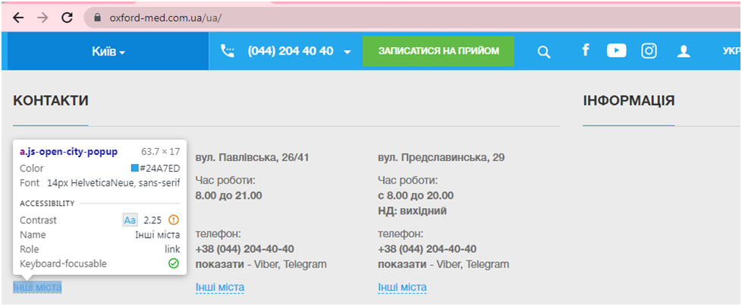

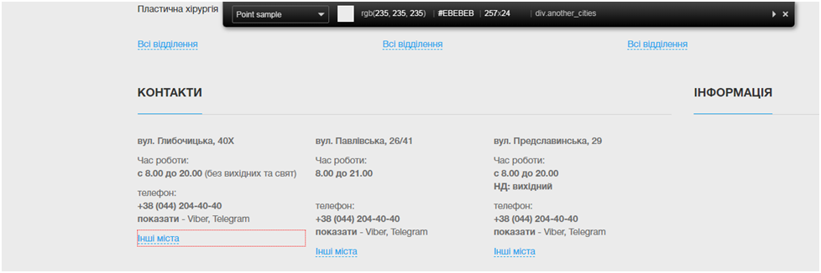

**4.** **Placeholder “ім’я” у формі “ЗАПИСАТИСЯ НА ПРИЙОМ”**

Шрифт та розмір: 14px/18px HelveticaNeue, sans-serif;

Колір: #6d6d6d color description : Very dark gray.

Колір бекграунду: #ffffff color description : White.

